**Project Deliverable 3 – Prototype & User Manual**

**Faculty Name:** Information Technology

**Module Code:** ITPJA3-34

**Module Name:** Project

**Module Leader:** Kariboba Mpwampu

**Copy Editor:** Mr Kyle Keens

**Submission Date:** Second Block Week 3

|  |  |
| --- | --- |
| **Group Name** | JPNL |
| **Group Number** |  |
| **Student Names** | Lily Beshi Emem Akpanke, Nelio Lino Nhacolo, Phemelo kenosi, Jonathan Milolo Beya |
| **Student Numbers** | 2m897pkl1 |
| **Project Title** |  |
| **Submission Date** |  |

Table of Contents

3.1. Introduction 3

3.2. Basics: Accessing your website and Admin 3

3.3. Prototyping 3

3.4. Coding 3

3.5. User Manual 4

3.6. Testing 4

3.7. Conclusion 4

3.8. Sign-off 5

## Introduction

**3.1.1 Introduction**

The design of this website requires two sides, namely the client side and the administrator side.

The development of the Website can be divided into three sections. First, we have the coding, second the database, third the Hosting. For the coding section, we are going to use the Microsoft Integrated Development Environment called “Visual Studio Code” or VSCode to read all the Hypertext Markup Language (HTML), Cascading Style Sheet (CSS), JS (JavaScript), and Hypertext Preprocessor (PHP). The database section is handled by the administration tool called “phpMyAdmin”. The later allows us to create our database with the specific tables containing columns having constraints as we need, and easily perform retrieval, update, and deletion on those tables.

Since the Website is primarily designed locally, we need a local server that will help us connect to the database in phpMyAdmin, hence the use of XAMPP.

Finally, the Website will be hosted online for public access. The chosen Web Host is AfriHost as it is located in South Africa and it has the hosting package that our website needs in order to be secure.

## Basics: Accessing your website and Admin

**3.2.1 Accessing the website**

[Provide and explain the links used to access the website for both customers and admin]

To access the website for both customers and admin, follow these steps:

For Customers:

1. Open your web browser.

2. Enter the following link in the address bar: ` https://mr-ranger.co.za/admin/admin_login.php `.

3. This will take you to the customer portal of the website.

Customer Registration:

4. On the customer portal, you will see a "Sign up" form.

5. Fill in the required information, such as title, first name, last name, email, phone number,

and password.

6. Click the "Sign up" button.

7. If registration is successful, you will see a message saying, "Registration successful!"

Customer Login:

8. To log in as a customer, you can use the "Sign in" form on the customer portal.

9. Enter your email and password.

10. Click the "Login" button.

11. If the login information is correct, you will be logged into the customer account.

For Admin:

1. Open your web browser.

2. Enter the following link in the address bar: `Admin.com`.

3. This will take you to the admin login page.

Admin Login:

4. On the admin login page, you will see a form.

5. Enter the admin username and password.

6. The default username is "Morne23," and the default password is "0123456789"

(as mentioned in the comments).

7. Click the "login now" button.

8. If the login information is correct, you will be logged into the admin dashboard.

Admin Accounts (Admin Dashboard):

9. Once logged in as an admin, you will have access to admin functionalities.

10. You can manage admin accounts, add new admin accounts, and perform other

administrative tasks.

**3.2.2 The Admin Area**

[Explain what this area is used for on your site. Include Images where possible.]

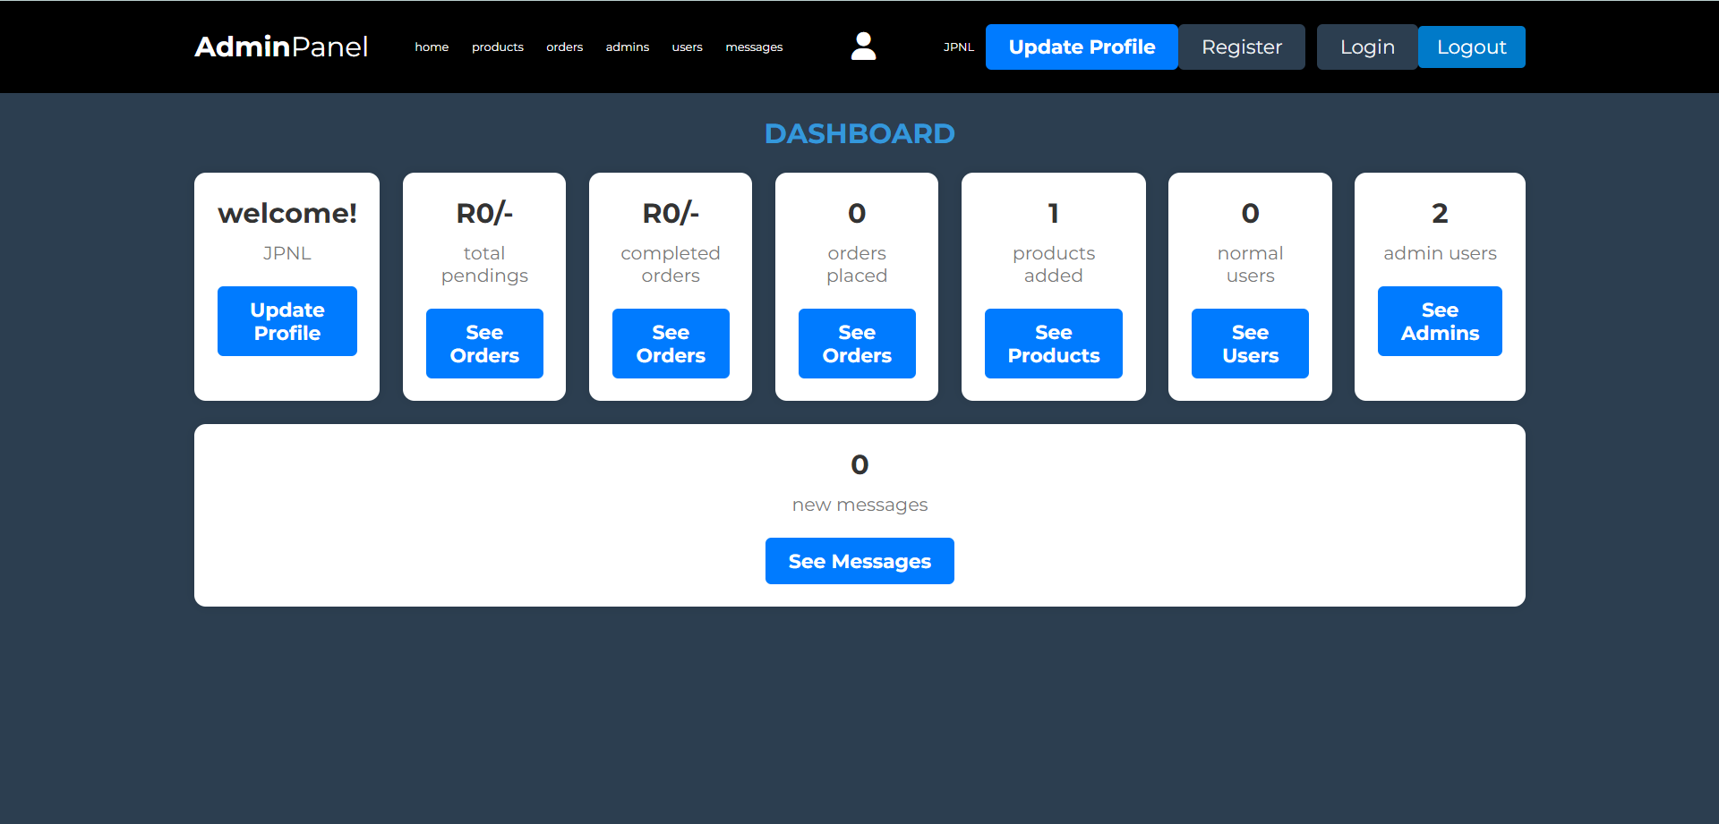

This admin area is used for managing and monitoring various aspects of the website.

This admin area is typically used for monitoring and managing various aspects of the website, such as user accounts, orders, products, and messages, and it provides administrators with a centralized interface to perform these tasks. It is a typical setup for an e-commerce or content management system with an admin panel.

Dashboard Section: The admin area features a dashboard section that displays various statistics and links to perform specific actions.

Welcome Box: It shows the name of the currently logged-in admin and provides a link to update the admin's profile.

Total Pending: This box displays the total number of pending orders. It calculates the total by fetching data from the database, where the payment status is 'pending.’

Completed Orders: This box displays the total number of completed orders, similar to the "Total Pending's" box but for orders with a 'completed' payment status.

Orders Placed: It displays the total number of orders placed.

Products Added: It displays the total number of products added.

Normal Users: This box shows the total number of normal users in the system.

Admin Users: This box displays the total number of admin users.

New Messages: It displays the number of new messages.

Report: That will show the necessary summary.

## Prototyping

Provide the screen shots of the two responsive prototypes asked in the project specification document. Each prototype must illustrate how all the pages of the website will be displayed on smart phones, tablets and desktops.

1. **Prototype 1.**

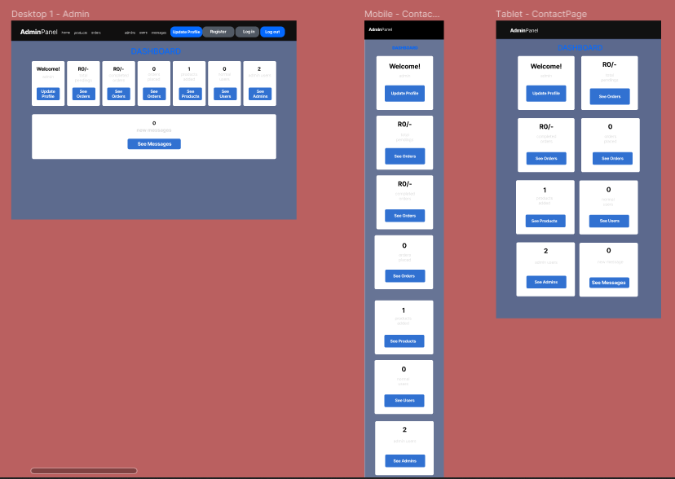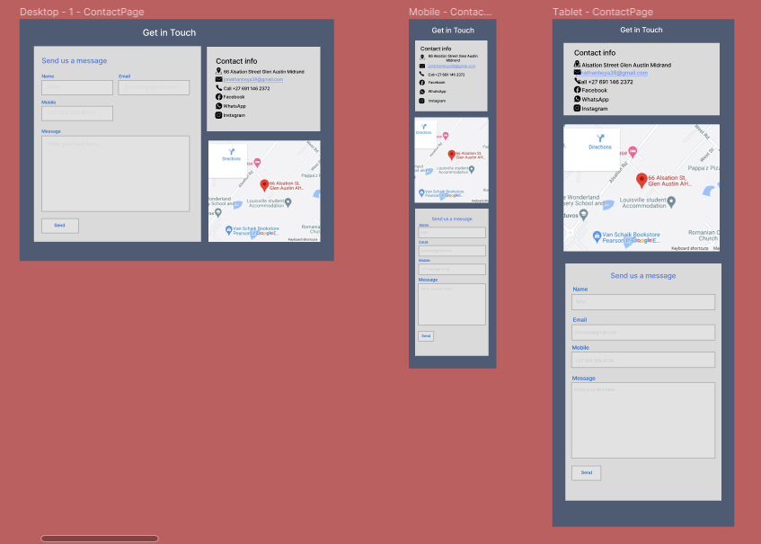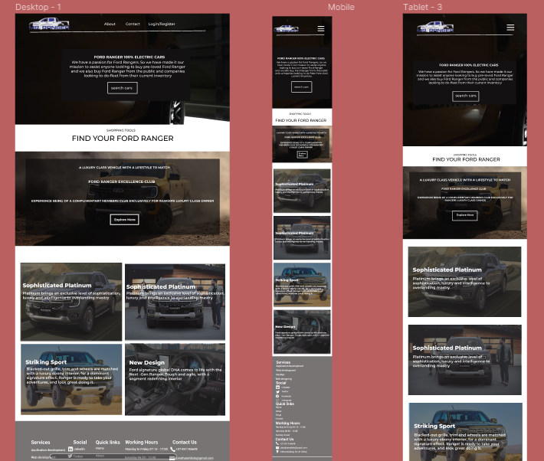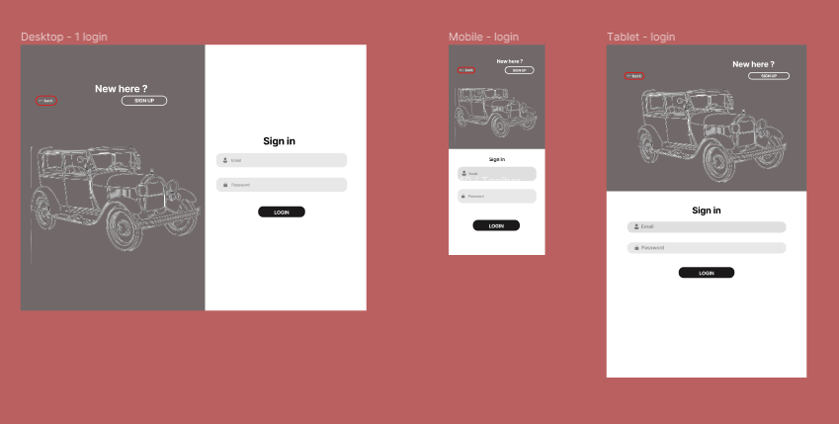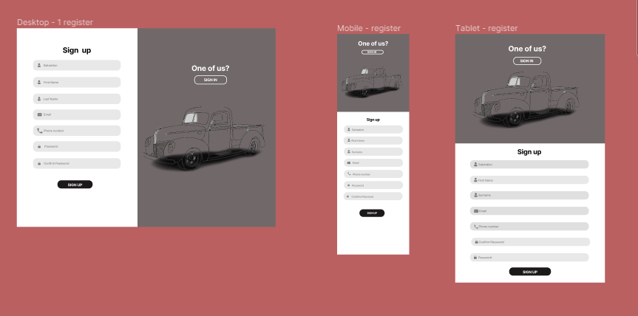

1. **Prototype 2.**

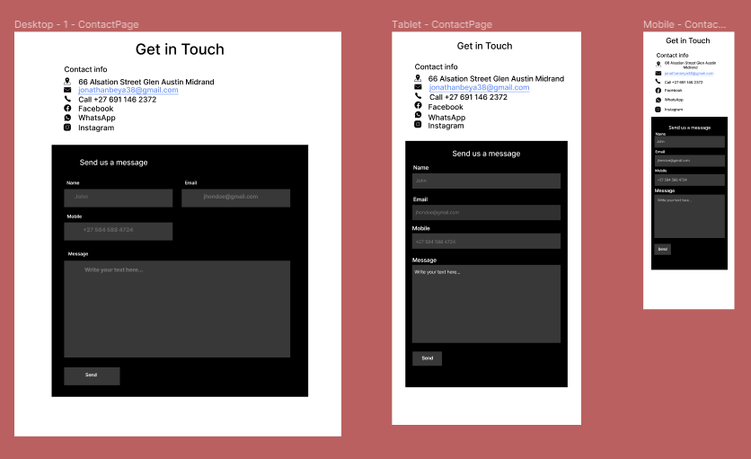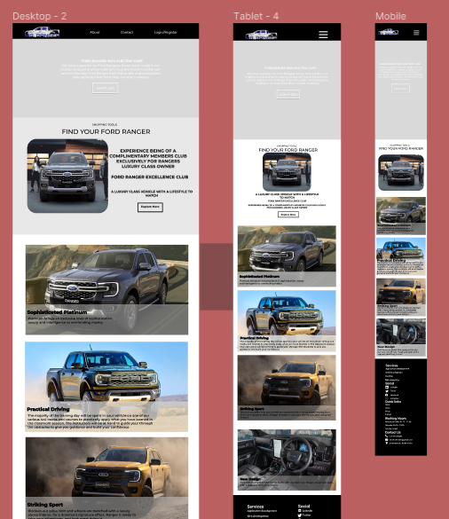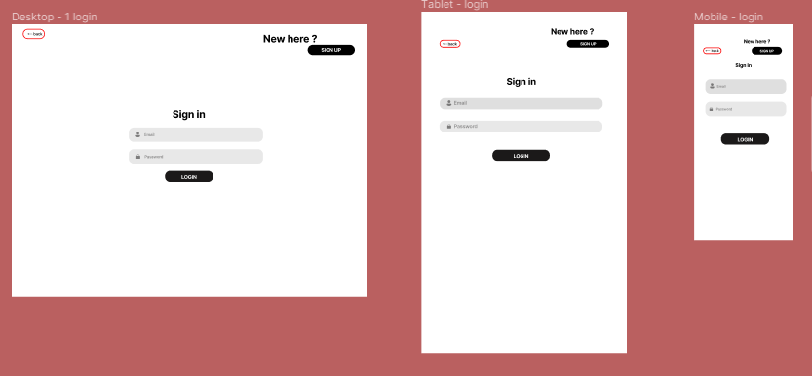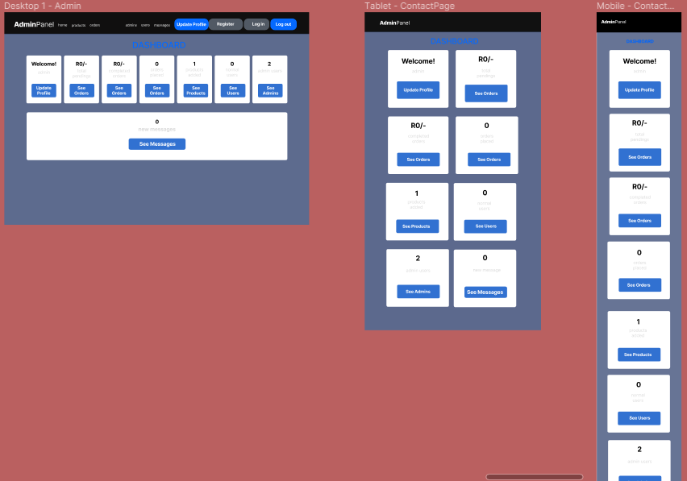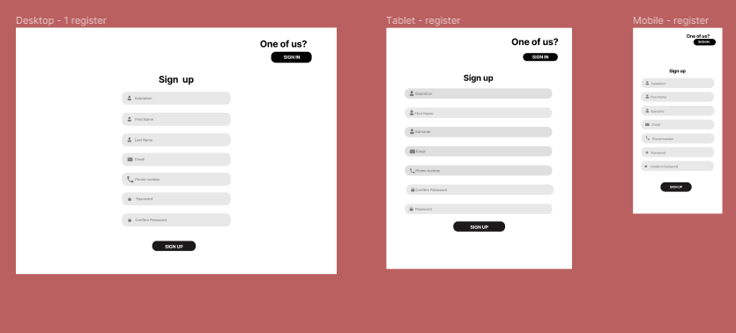

**OUR CLIENT CHOSE PROTOTYPE 1**

## Coding

1. **Screenshots**

**Home page**

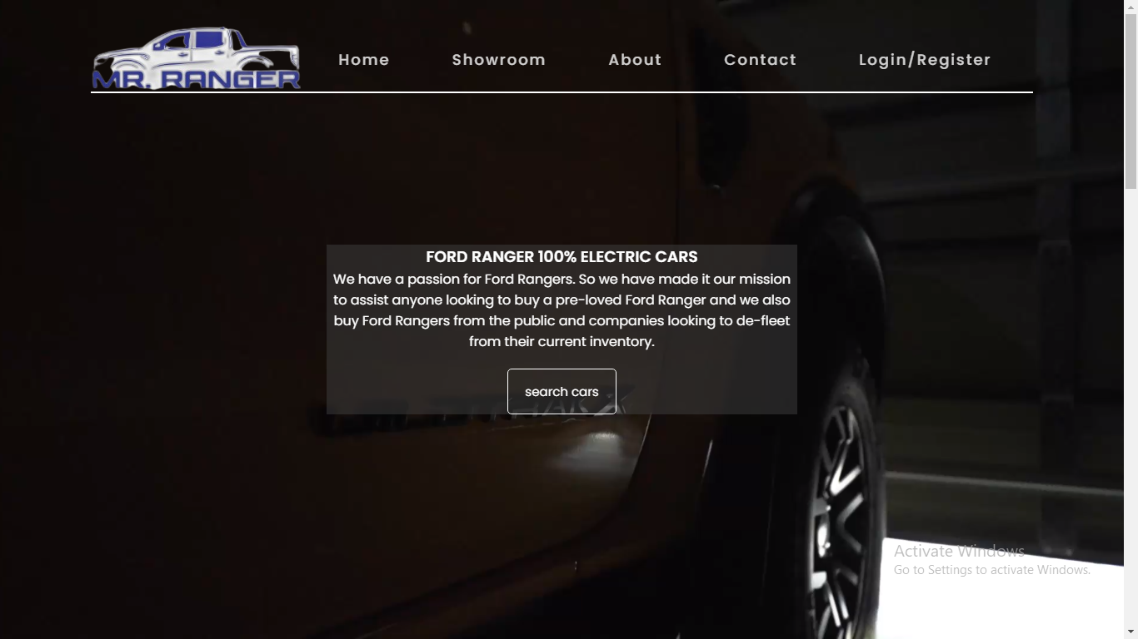

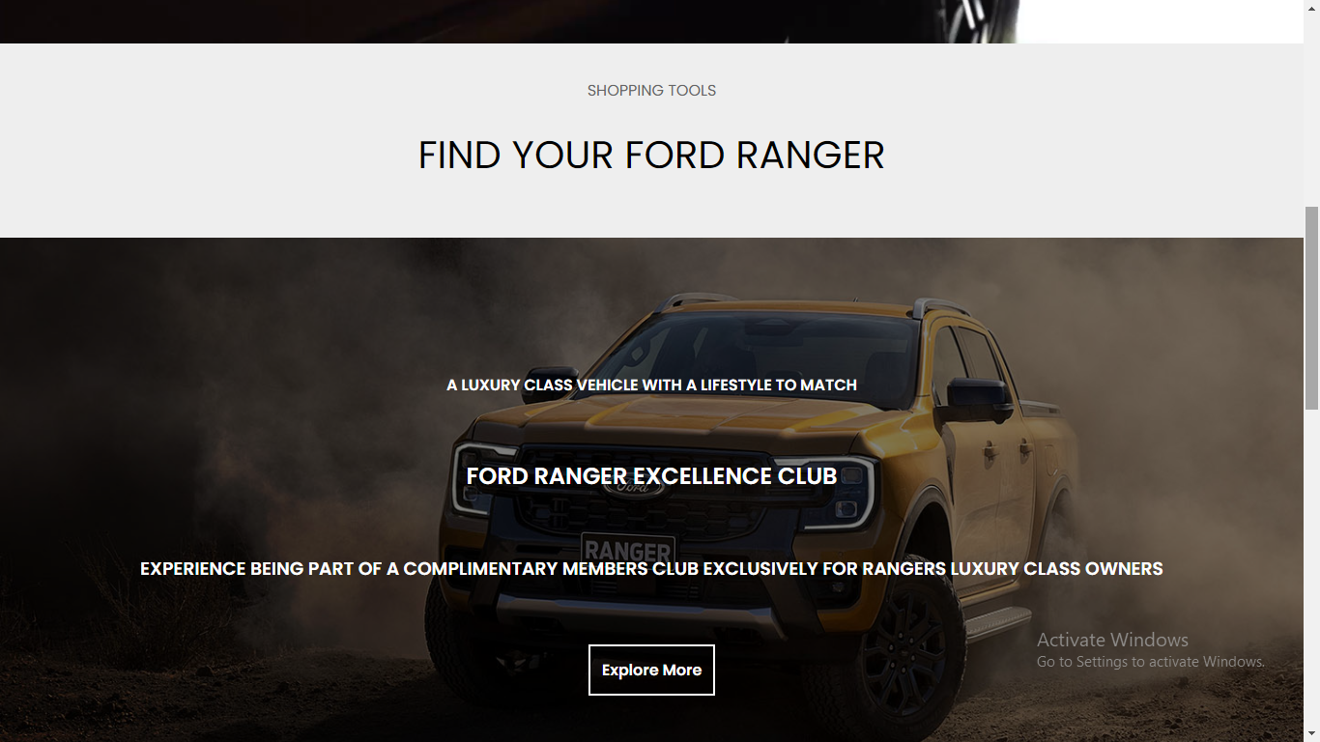

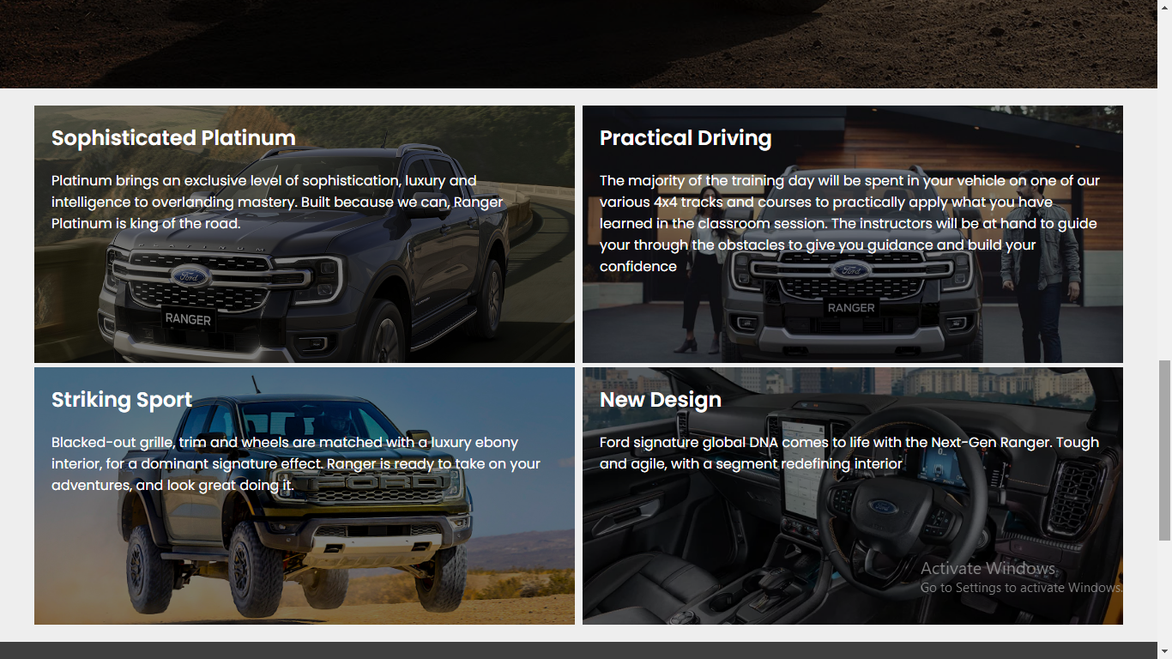

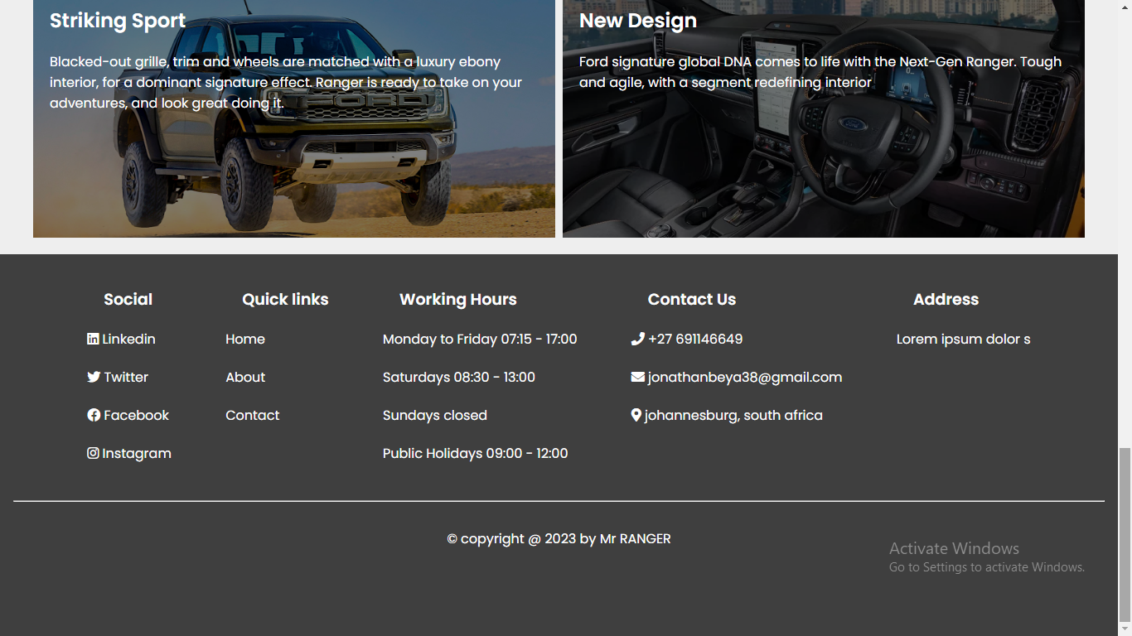

1. **Sample PHP Code** **for the Home page**

<?php

   if(isset($message)){

      foreach($message as $message){

         echo '

         <div class="message">

            <span>'.$message.'</span>

            <i class="fas fa-times" onclick="this.parentElement.remove();"></i>

         </div>

         ';

      }

   }

?>

<?php

include 'components/connect.php';

session_start();

if(isset($_SESSION['user_id'])){

   $user_id = $_SESSION['user_id'];

}else{

   $user_id = '';

};

?>

1. **Sample HTML Code for the Home page**

<section class="thirdSection">

   <div class="flexbox">

      <div class="zoom first">

         <div class="overlay">

            <h2>Sophisticated Platinum</h2>

            <p>Platinum brings an exclusive level of sophistication, luxury and intelligence to overlanding mastery. Built because we can, Ranger Platinum is king of the road.</p>

         </div>

      </div>

      <div class="zoom second">

         <div class="overlay">

            <h2>Practical Driving</h2>

            <p>The majority of the training day will be spent in your vehicle on one of our various 4x4 tracks and courses to practically apply what you have learned in the classroom session. The instructors will be at hand to guide your through the obstacles to give you guidance and build your confidence</p>

         </div>

      </div>

      <div class="zoom mar third">

         <div class="overlay">

            <h2>Striking Sport</h2>

            <p>Blacked-out grille, trim and wheels are matched with a luxury ebony interior, for a dominant signature effect. Ranger is ready to take on your adventures, and look great doing it.</p>

         </div>

      </div>

      <div class="zoom mar fourth">

         <div class="overlay">

            <h2>New Design</h2>

            <p>Ford signature global DNA comes to life with the Next-Gen Ranger. Tough and agile, with a segment redefining interior</p>

         </div>

      </div>

   </div>

</section>

1. **Sample JavaScript Code for the Home page**

const bar = document.getElementById('bar');

const nav = document.getElementById('navbar1');

const close = document.getElementById('close');

if(bar) {

    bar.addEventListener('click', () => {

        nav.classList.add('active');

    })

}

if(close){

    close.addEventListener('click', () =>{

        nav.classList.remove('active');

    })

}

1. **Sample CSS Code for the Home page**

  .header{

   width: 100%;

   background-color: transparent;

   padding-top: 10px;

  }

  .header .nav-bar{

   width: 90%;

   height: 80px;

   line-height: 80px;

   margin: auto;

   color: #fff;

   display: flex;

   justify-content: space-between;

   border-bottom: 2px solid #fff;

  }

  .header .nav-bar .logo{

   z-index: 2;

   margin-right: 26px;

  }

  .header .nav-bar .logo a{

   color: #fff;

   font-size: 30px;

   font-weight: 700;

   text-transform: uppercase;

  }

  /* .header .nav-bar .logo img{

    border-radius: 10px;

   } */

  .header .nav-bar .menu{

   z-index: 2;

  }

  .header .nav-bar ul li{

   margin-right: 30px;

  }

  .header .nav-bar .menu ul li a{

   font-size: 18px;

   font-weight: 500;

   letter-spacing: 2px;

   padding: 20px;

   border-radius: 5px;

   text-transform: capitalize;

   transition: all 0.5s;

   opacity: 0.8;

   color: #fff;

  }

  #menu-btn{

    display: none;

 }

  /* .header .nav-bar .menu ul li a.active{

   opacity: 1;

   background-color: #fff;

   color: #000;

  } */

  .header .nav-bar .menu ul li a:hover{

   opacity: 1;

   background-color: #fff;

   color: #000;

  }

  .header .nav-bar .icons{

   z-index: 2;

  }

  .header .nav-bar .icons a i{

   color: #fff;

   width: 45px;

   height: 45px;

   line-height: 45px;

   margin-right: 5px;

   text-align: center;

   align-items: center;

   font-size: 19px;

   border-radius: 5px;

   background-color: #cac5c542;

   box-shadow: 0 0 25px rgba(24,24,24,.4);

   transition: all 0.3s;

  }

  .header .nav-bar .icons a span{

    color: white;

  }

  .header .nav-bar .icons a i:hover{

   background-color: #fff;

   color: #000;

  }

  #mobile{

    display: none;

    align-items: center;

  }

  #close{

    position: absolute;

    top: 30px;

    left: 30px;

    color: #000;

    font-size: 24px;

    display: none;

  }

1. **Sample MySQL Table Screenshots (this is the same for all the pages of the Website)**

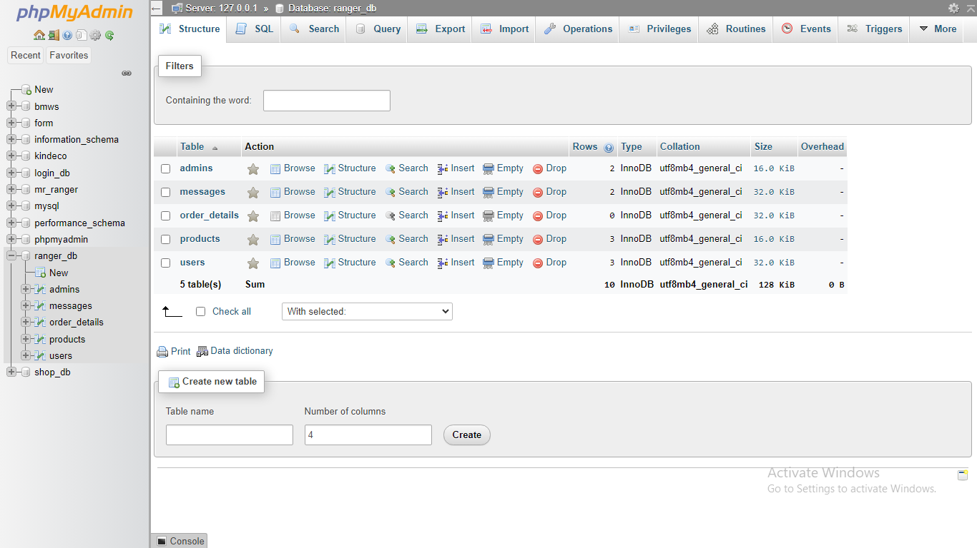

**Contact page**

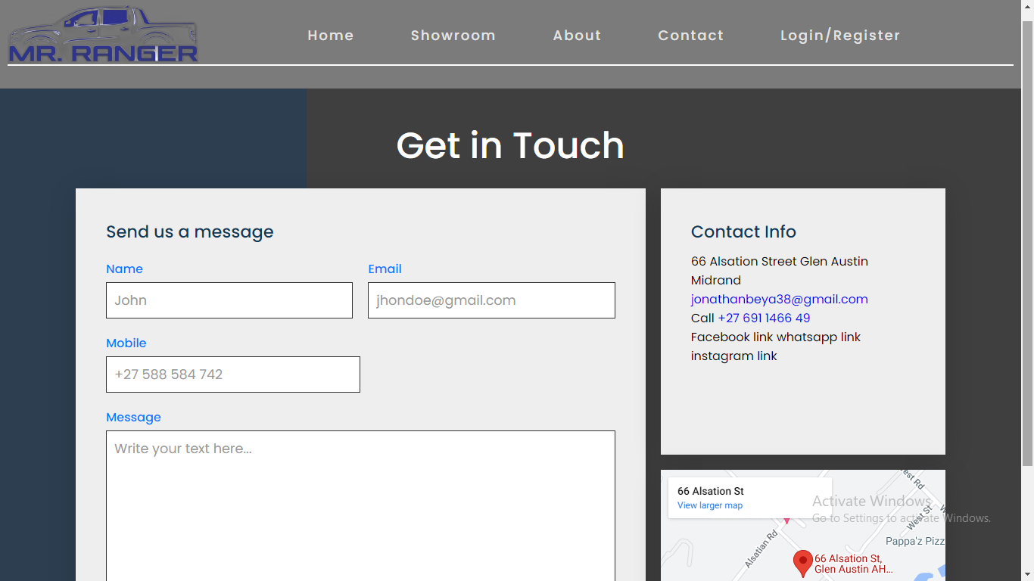

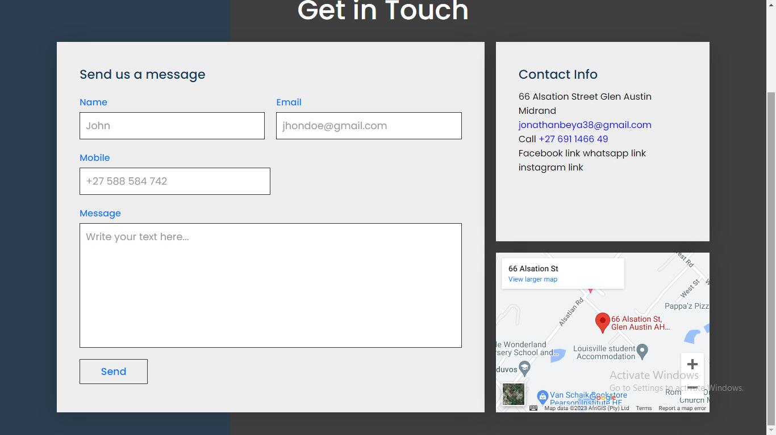

**PHP code for the contact page**

<?php

include 'components\connect.php';

session_start();

if(isset($_SESSION['id'])){

   $id = $_SESSION['id'];

}else{

   $id = '';

};

if(isset($_POST['send'])){

   $name = $_POST['name'];

   $name = filter_var($name, FILTER_SANITIZE_STRING);

   $email = $_POST['email'];

   $email = filter_var($email, FILTER_SANITIZE_STRING);

   $number = $_POST['number'];

   $number = filter_var($number, FILTER_SANITIZE_STRING);

   $msg = $_POST['msg'];

   $msg = filter_var($msg, FILTER_SANITIZE_STRING);

   $select_message = $conn->prepare("SELECT * FROM `messages` WHERE name = ? AND email = ? AND number = ? AND message = ?");

   $select_message->execute([$name, $email, $number, $msg]);

   if($select_message->rowCount() > 0){

      $message[] = 'already sent message!';

   }else{

      $insert_message = $conn->prepare("INSERT INTO `messages`(name, email, number, message) VALUES(?,?,?,?)");

      $insert_message->execute([$name, $email, $number, $msg]);

      $message[] = 'sent message successfully!';

   }

}

?>

**HTML code for the contact page**

        <div class="theHeader">

            <?php include 'components\home_header.php';?>

        </div>

        <div class="contactUs">

            <div class="title">

                <h2>Get in Touch</h2>

            </div>

            <div class="box">

                <!-- form -->

                <div class="contact form">

                    <h3>Send us a message</h3>

                    <form action="" method="post">

                        <div class="formBox">

                            <div class="row50">

                                <div class="inputBox">

                                    <span>Name</span>

                                    <input type="text" name="name" placeholder="John" required maxlength="20">

                                </div>

                                <div class="inputBox">

                                    <span>Email</span>

                                    <input type="email" name="email" placeholder="jhondoe@gmail.com" required maxlength="50">

                                </div>

                            </div>

                            <div class="row50">

                                <div class="inputBox">

                                    <span>Mobile</span>

                                    <input type="number" name="number" min="0" max="9999999999" placeholder="+27 588 584 742">

                                </div>

                            </div>

                            <div class="row100">

                                <div class="inputBox">

                                    <span>Message</span>

                                    <textarea name="msg" placeholder="Write your text here..."></textarea>

                                </div>

                            </div>

                            <div class="row100">

                                <div class="inputBox">

                                    <input type="submit" name="send" value="Send">

                                </div>

                            </div>

                        </div>

                    </form>

                </div>

**The contact page does not need any Javascript.**

**CSS code for the Contact page**

.theHeader{

    background-color: #7b7b7b;

    padding: 0 10px;

    height: 120px;

    width: 100%;

    top: 0;

}

.contactUs{

    position: relative;

    width: 100%;

    padding: 40px 100px;

}

.contactUs .title{

    display: flex;

    justify-content: center;

    align-items: center;

    font-size: 2em;

}

.contactUs .title h2{

    color: white;

    font-weight: 500;

}

.form{

    grid-area: form;

}

.info{

    grid-area: info;

}

.map{

    grid-area: map;

}

.contact{

    padding: 40px;

    background: rgb(238,238,238);

    box-shadow: 0 5px 35px rgba(0,0,0,0.15);

}

.box{

    position: relative;

    display: grid;

    grid-template-columns: 2fr 1fr;

    grid-template-rows: 5fr 4fr;

    grid-template-areas:

    "form info"

    "form map";

    grid-gap: 20px;

    margin-top: 20px;

}

.contact h3{

    color: #0e3959;

    font-weight: 500;

    font-size: 1.4em;

    margin-bottom: 10px;

}

/* form */

.formBox{

    position: relative;

    width: 100%;

}

.formBox .row50{

    display: flex;

    gap: 20px;

}

.inputBox{

    display: flex;

    flex-direction: column;

    margin-bottom: 10px;

    width: 50%;

}

.formBox .row100 .inputBox{

    width: 100%;

}

.inputBox span{

    color: #007bff;

    margin-top: 10px;

    margin-bottom: 5px;

    font-weight: 500;

}

.inputBox input{

    padding: 10px;

    font-size: 1.1em;

    outline: none;

    border: 1px solid #333;

}

.inputBox textarea{

    padding: 10px;

    font-size: 1.1em;

    outline: none;

    border: 1px solid #333;

    resize: none;

    min-height: 220px;

    margin-bottom: 10px;

}

.inputBox input[type="submit"]{

    background: transparent;

    color: #007bff;

    border: 1px solid #333;

    font-size: 1.1em;

    max-width: 120px;

    font-weight: 500;

    cursor: pointer;

    padding: 8px 9px;

}

.inputBox ::placeholder{

    color: #999;

}

.contact .infoBox a{

    text-decoration: none;

}

.contact .infoBox a:hover{

    text-decoration: underline;

}

.map{

    padding: 0;

}

.map iframe{

    width: 100%;

    height: 100%;

}

**The Login/Registration page**

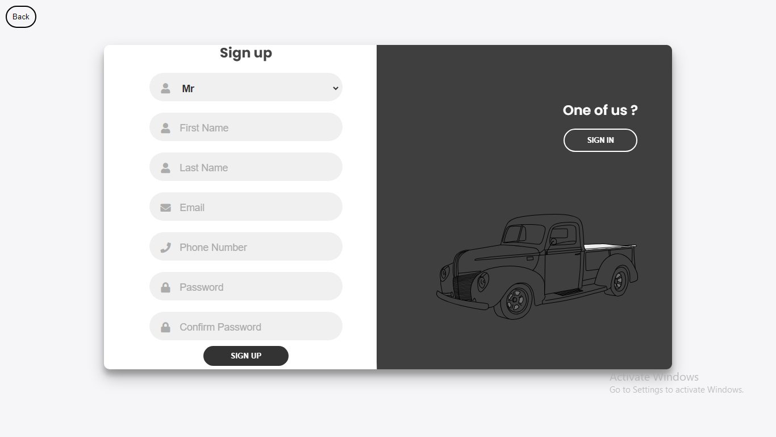

**PHP code for the Login/Register page**

<?php

// Check if the form is submitted

if ($_SERVER["REQUEST_METHOD"] == "POST") {

  // Retrieve the form data

  $salutation = $_POST["salutation"];

  $firstName = $_POST["first_name"];

  $lastName = $_POST["last_name"];

  $email = $_POST["email"];

  $password = $_POST["password"];

  $phone = $_POST["phone"];

  // Your database connection code here

  // Replace 'your_db_host', 'your_db_username', 'your_db_password', and 'your_db_name' with your actual database credentials

  $conn = new mysqli('', 'root', '', 'ranger_db');

  $servername = "localhost";

  $username = 'root';

  $password = '';

  $dbname = "ranger_db";

  if ($conn->connect_error) {

    die("Connection failed: " . $conn->connect_error);

  }

  // You should use a secure password hashing method like bcrypt in a real-world scenario

  $hashedPassword = password_hash($password, PASSWORD_DEFAULT);

  // SQL query to insert data into the database table

  $sql = "INSERT INTO registration (salutation, first_name, last_name, email, phone, password) VALUES ('$salutation', '$firstName', '$lastName', '$email', '$phone', '$hashedPassword')";

  if ($conn->query($sql) === TRUE) {

    echo "Registration successful!";

  } else {

    echo "Error: " . $sql . "<br>" . $conn->error;

  }

  $conn->close();

}

?>

**HTML code for the Login/Register page**

      <form action="login.php" class="sign-in-form" method="post">

          <!-- Add name attribute to input fields for form data submission -->

          <h2 class="title">Sign in</h2>

          <div class="input-field">

            <i class="fas fa-user"></i>

            <input type="email" name="email" placeholder="Email" required />

          </div>

          <div class="input-field">

            <i class="fas fa-lock"></i>

            <input type="password" name="password" placeholder="Password" required />

          </div>

          <input type="submit" value="Login" class="btn solid" />

        </form>

        <form action="register.php" class="sign-up-form" method="post">

          <h3 class="title">Sign up</h3>

          <div class="input-field">

              <i class="fas fa-user"></i>

              <select name="salutation" required>

                  <option value="Mr">Mr</option>

                  <option value="Mrs">Mrs</option>

                  <option value="Dr">Dr</option>

                  <option value="Miss">Miss</option>

              </select>

          </div>

          <div class="input-field">

              <i class="fas fa-user"></i>

              <input type="text" name="first_name" placeholder="First Name" pattern="[A-Za-z]+" required />

          </div>

          <div class="input-field">

              <i class="fas fa-user"></i>

              <input type="text" name="last_name" placeholder="Last Name" pattern="[A-Za-z]+" required />

          </div>

          <div class="input-field">

              <i class="fas fa-envelope"></i>

              <input type="email" name="email" placeholder="Email" required />

          </div>

          <div class="input-field">

              <i class="fas fa-phone"></i>

              <input type="tel" name="phone" placeholder="Phone Number" pattern="[0-9]{10}" required />

          </div>

          <div class="input-field">

            <i class="fas fa-lock"></i>

            <input type="password" name="password" placeholder="Password" required />

          </div>

          <!-- Add Confirm Password Field -->

          <div class="input-field">

            <i class="fas fa-lock"></i>

            <input type="password" name="confirm_password" placeholder="Confirm Password" required />

          </div>

          <input type="submit" class="btn mar" value="Sign up" />

          <!-- ... Rest of the form ... -->

        </form>

**Javascript code for the Login/Register page**

const sign_in_btn = document.querySelector("#sign-in-btn");

const sign_up_btn = document.querySelector("#sign-up-btn");

const container = document.querySelector(".container");

sign_up_btn.addEventListener("click", () => {

  container.classList.add("sign-up-mode");

});

sign_in_btn.addEventListener("click", () => {

  container.classList.remove("sign-up-mode");

});

**CSS code for the Login/Register page**

.container {

    background: #fff;

    border-radius: 10px;

    box-shadow: 0 14px 28px rgba(0, 0, 0, 0.25), 0 10px 10px rgba(0, 0, 0, 0.22);

    position: relative;

    overflow: hidden;

    width: 100%;

    max-width: 1000px;

    min-height: 570px;

}

.forms-container {

  position: absolute;

  width: 100%;

  height: 100%;

  top: 0;

  left: 0;

}

.signin-signup {

  position: absolute;

  top: 50%;

  transform: translate(-50%, -50%);

  left: 75%;

  width: 50%;

  transition: 1s 0.7s ease-in-out;

  display: grid;

  grid-template-columns: 1fr;

  z-index: 5;

}

form {

  display: flex;

  align-items: center;

  justify-content: center;

  flex-direction: column;

  padding: 0rem 5rem;

  transition: all 0.2s 0.7s;

  overflow: hidden;

  grid-column: 1 / 2;

  grid-row: 1 / 2;

}

form.sign-up-form {

  opacity: 0;

  z-index: 1;

}

form.sign-up-form .mar{

  margin-top: 0;

  height: 35px;

}

form.sign-in-form {

  z-index: 2;

}

## User Manual

USER MANUAL

3.1. Introduction 2

3.2. Basics: Accessing your website and Admin 3

3.3. Prototyping 5

3.4. Coding 8

3.5. User Manual 8

System Requirements 8

Installation: NOT Applicable 8

User Interface: 8

Main Features: 8

Step-by-step Instructions: 8

3.6. For Clients 8

How to Login 8

How to register 8

How to search for available cars: 8

How to place an order (make an enquiry): 8

How to contact Mr. Ranger: 8

How to logout: 8

3.7. For Admin 8

How to login 8

How to register a new admin: 8

How to view orders: 8

How to view/edit available products: 8

How to view/edit client account details: 8

How to view messages: 8

How to logout: 8

3.8. Testing 8

3.9. Conclusion 8

3.10. Sign-off 8

# System Requirements

Definition: A system must have specific configurations/ meet the requirements needed for a certain application. This is so that the application can run efficiently.

1. The system used for browsing should have hardware and software that support common web application technologies such as HTML5, CSS3, JavaScript.
2. Internet Access
3. Must be able to run a web browser
4. The system must be compatible with the chosen web browser. System Requirements differ according to which web browser you are using.

|  |  |  |
| --- | --- | --- |
| CHROME ON WINDOWS OPERATING SYSTEM | | |
| Processor | Min RAM | Oldest Operating System Version Allowed |
| Pentium 4 | 128 MB | Windows XP SP2 |
| CHROME ON MAC OPERATING SYSTEM | | |
| Intel | 128 MB | OS X 10.5.6 |
| FIREFOX ON WINDOWS OPERATING SYSTEM | | |
| Pentium 4 | 512 MB | Windows XP SP2 (FF 13) |
| FIREFOX ON MAC OPERATING SYSTEM | | |
| Intel | 512 MB | OS X 10.5 |

## Installation: NOT Applicable

## User Interface:

**CONTACT PAGE**

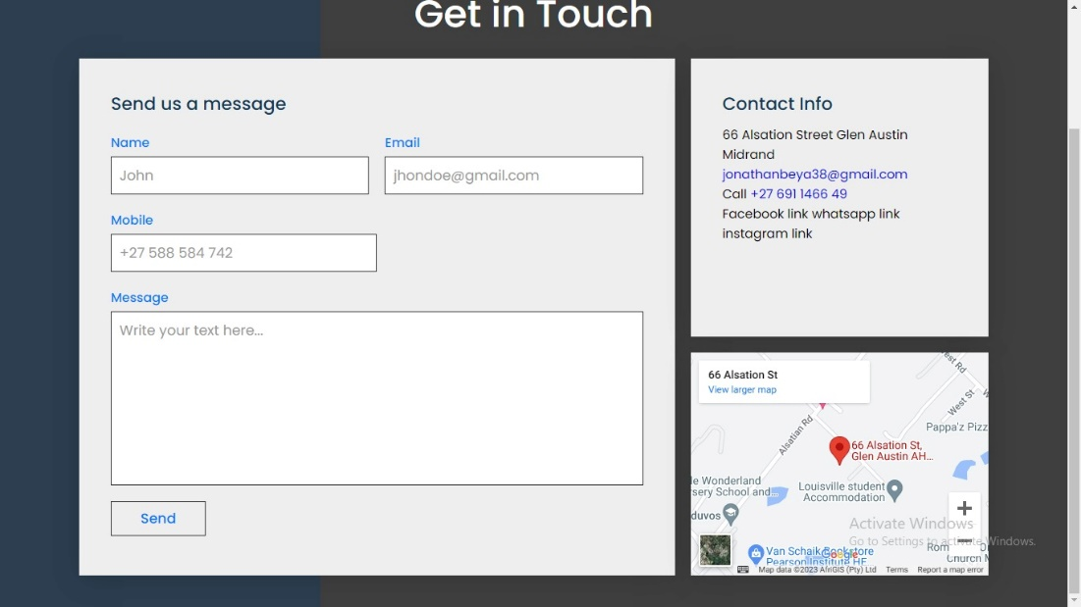

**ABOUT PAGE**



**HOME PAGE**

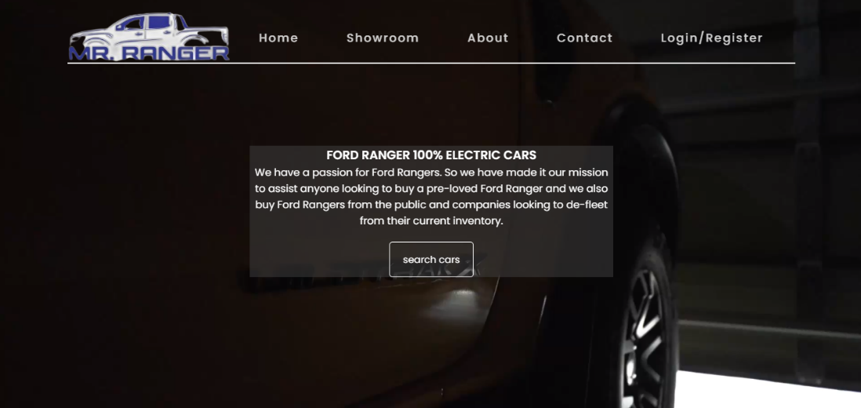

**ADMIN LOGIN**  
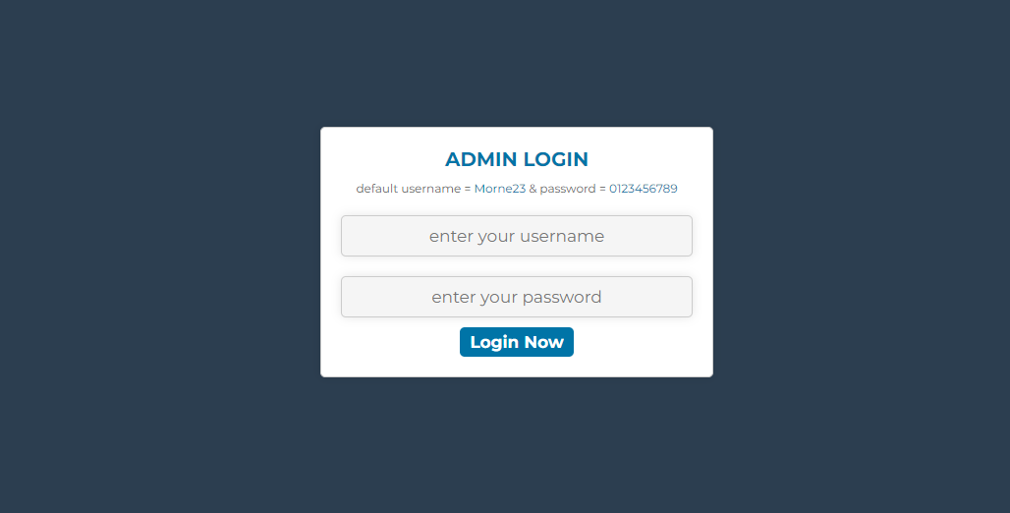  
**ADMIN ACCOUNTS**  
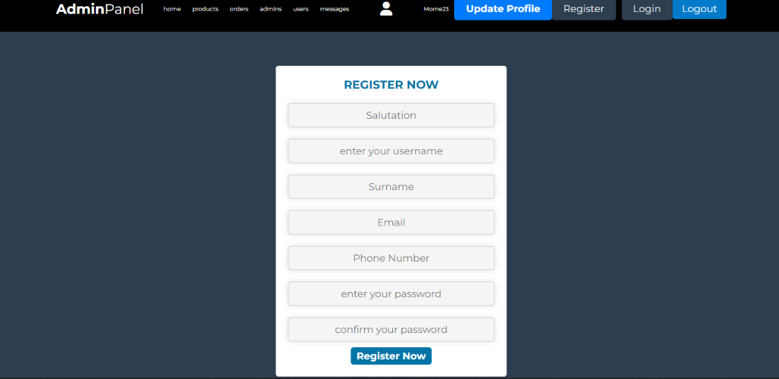

ADMIN MESSAGES  
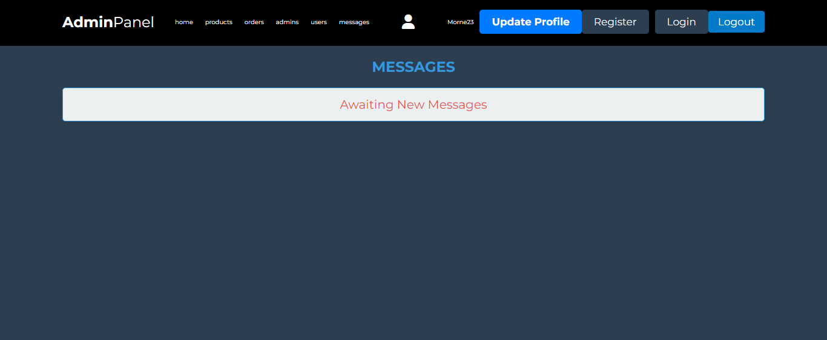

## Main Features:

**LOGIN PAGE**

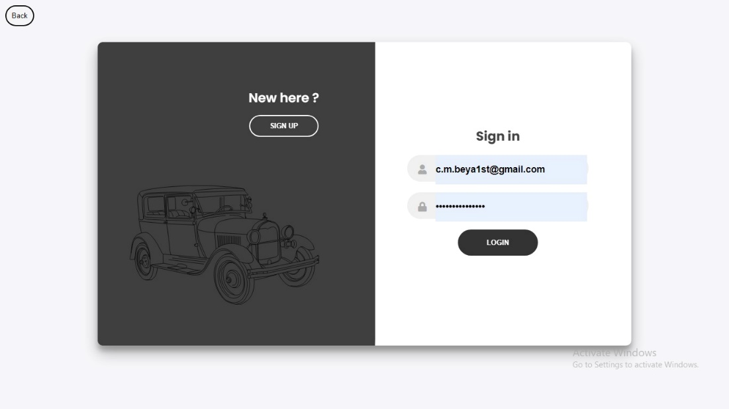

**REGISTER PAGE**   
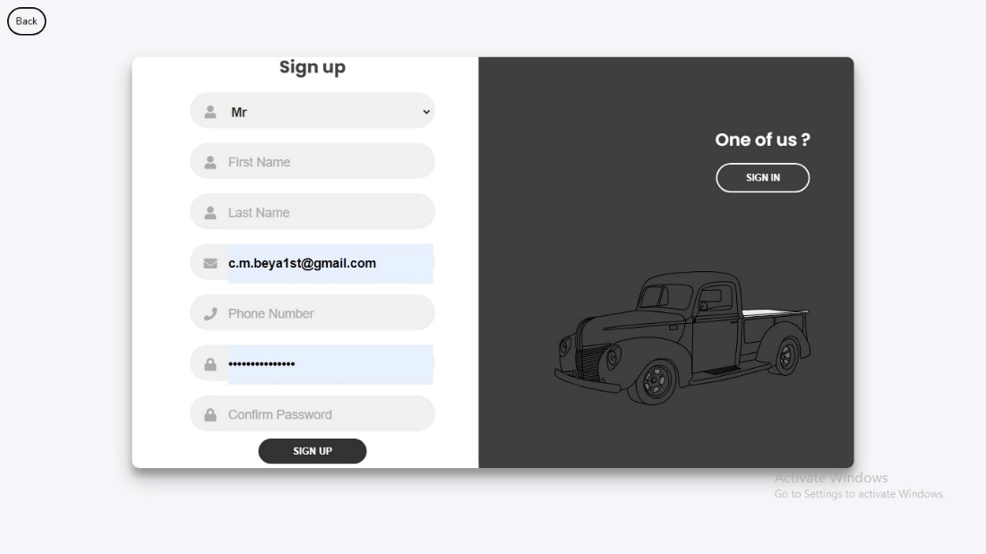**S**

**SHOW ROOM**  
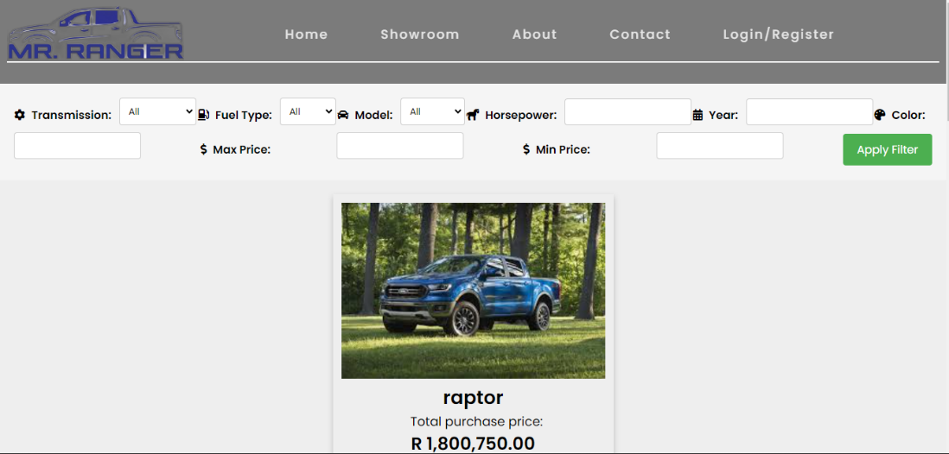

**PAYMENT GATEWAY/ CHECKOUT PAGE**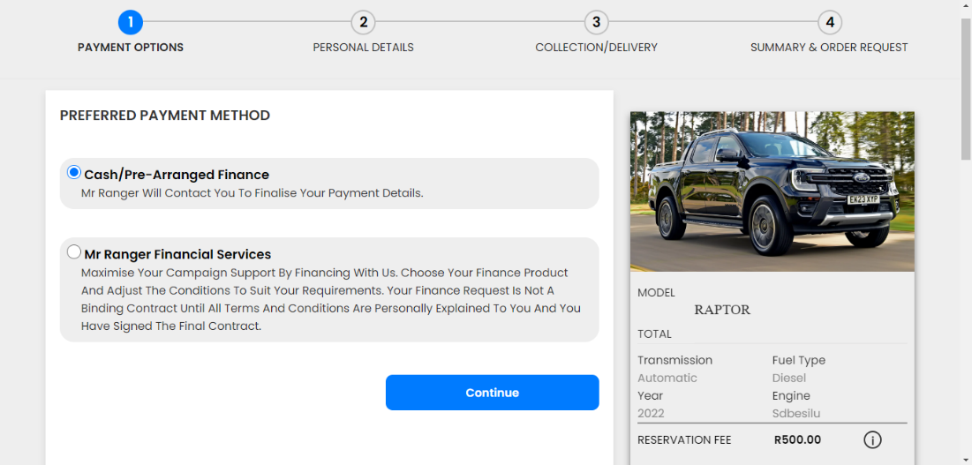

**ADDING NEW PRODUCTS**

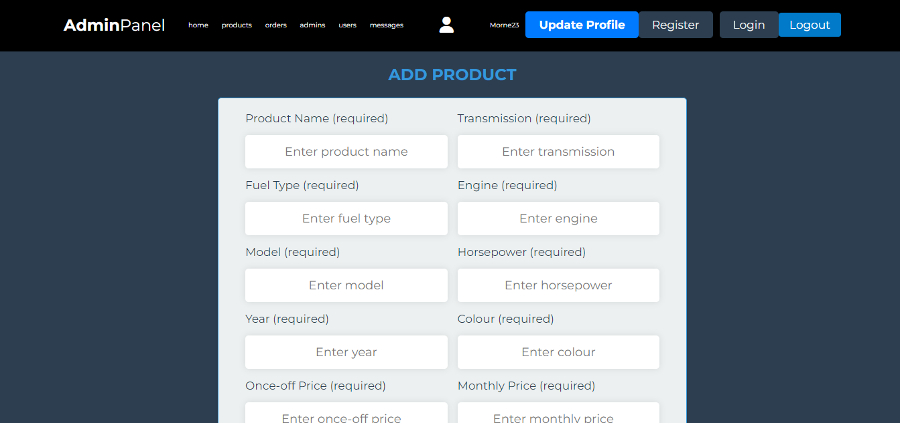

## Step-by-step Instructions:

## For Clients

### How to Login

1. From any page on the website. Locate the navigation bar at the top of the screen.
2. Locate the ‘Login/Register’ button in the navigation bar and click it.
3. Once on the login and registration page, you should be automatically placed in the login section.
4. Fill in the two required fields (email and password) on the form.
5. Click the 'login’ if your details are correct, you will be redirected back to the page you were previously on. However, if your details are not correct you will be notified and requested to input accurate information.

### How to register

1. If you do not already have an account, locate the signup button on the top left of the form and click it.
2. Fill in all the required details.
3. Click the ‘sign up’ which will validate and save your information. You will receive an error message if any of your inputs are inadequate. If successful you will be returned to the login section.
4. Using the email and password details that you specified in the registration section, login to your newly created account.

### How to search for available cars:

1. From any page on the website. Locate the navigation bar at the top of the screen.
2. In the navigation bar locate and click on the ‘Showroom’ button.
3. In the filter section you can narrow down your search option. By selecting either transmission horsepower, year, color max and minimum price that you are willing to pay.
4. Click ‘apply filter’ to apply the changes you’ve made

### How to place an order (make an enquiry):

1. In the showroom once you’ve selected a specific car, locate the ‘buy and explore’ button and click it to enter the quick view.
2. In the quick view you will find more details on the car. Scroll down to find the ‘order’ button. You will be taken to the checkout page, to place an order
3. Select your preferred payment method and enter all the required information. Once you complete a section of the form click the ‘continue’ button to proceed to the next stage.
4. On the summary page, take note of all the charges associated with the purchase of the car. It is important to note the standard reservation fee of R500. Once reviewed, click ‘continue’ to proceed to the ‘payment and invoice’ page
5. On the ‘payment and invoice’ page, input your card details to process the payment for your car reservation.
6. Once completed click the ‘Checkout’ button. This will process your payment and you will receive an email with an invoice to confirm your reservation along with other details regarding the car you have chosen to reserve.

### How to contact Mr. Ranger:

1. From any page on the website. Locate the navigation bar at the top of the screen.
2. In the navigation bar locate and click the ‘contact’ button
3. Once on the contact page fill in all required information and click on the ‘send’ button.
4. Clicking on the social media icons provided will allow you to communicate with Mr. Ranger through the selected platform of your choosing.

### How to logout:

1. Locate the navigation bar at the top of the screen
2. Find the ‘logout’ and click it

## For Admin

### How to login

1. Use the admin link to access the admin section of the website
2. Enter the admin username and password
3. Click the ‘login’ button

### How to register a new admin:

1. In the admin panel locate the navigation bar at the top of the screen
2. In the navigation bar, locate the ‘admins’ option and click it.
3. On the admins page click the ‘register admin’ button
4. Fill in the required information and click the ‘register now’ button

### How to view orders:

1. Locate the navigation bar at the top of the screen
2. Find the ‘orders’ option and click it
3. Alternatively, on the admin home page you can click on ‘see orders’

### How to view/edit available products:

1. On the navigation bar at the top of the screen locate the ‘products’ option and click it
2. Alternatively, on the admin home page you can click on the ‘see products’ button
3. On the products page you can access various tools to edit product details

### How to view/edit client account details:

1. On the navigation bar at the top of the screen locate the ‘users’ option and click it
2. Alternatively, on the admin home page you can click on the ‘see users’ button
3. On the users page you can access various tools to edit user account details

### How to view messages:

1. Locate the navigation bar at the top of the screen
2. Find the ‘messages’ option and click it
3. Alternatively, on the admin home page you can click on ‘see messages’

### How to logout:

1.Locate the navigation bar at the top of the screen

2.Find the ‘logout’ and click it

## Testing

1. Data Validation testing: Here we test to ensure that users can receive feedback on whether the information they input is valid and complete. We will do this by ensuring that the right error messages and prompts are given to the user when they input information, as well as testing to ensure the code is able to identify these issues and give prompts when needed.
2. Unit testing: Here we test small parts of our website thoroughly to see if they function accurately. We will do this by running the code for each individual part of the website separately, ensuring that they function and produce the needed results.
3. Usability testing: Here we will need to test if users are able to accomplish tasks using the website. Will do this by asking users to interact with our website and we will be able to gage how well the system is functioning by observing if users are able to successfully accomplish each task they require.

## Conclusion

In conclusion, the development of Mr. Swaart Morne's car dealership website has been a comprehensive process, covering various aspects of web development.

In the introduction, we outlined the technologies used to create the system, setting the stage for the project's scope and objectives.

In the Basics section, we provided clear instructions on how customers and administrators can access the website. For customers, registration and login processes were explained in detail, ensuring a smooth onboarding experience. Admins were guided on how to access the admin dashboard.

The Admin Area was briefly described, emphasizing its importance in managing the website's operations, with the inclusion of relevant images.

In the Prototyping section, we showcased responsive prototypes for different devices, allowing Mr. Swaart Morne to make an informed choice for the website's development.

The Coding section, though not provided in this document, encompasses screenshots and code samples for the final website. It includes PHP, HTML, JavaScript, CSS code samples, and MySQL table screenshots, demonstrating the technical implementation of the website.

The User Manual was emphasized as a vital component, providing end-users with comprehensive guidance on using the website effectively. It covers system requirements, installation (if applicable), user interface, main features, step-by-step instructions, FAQs, and a glossary, ensuring a user-friendly experience.

Lastly, the Testing section outlines the various testing processes that will be carried out, including unit testing, system testing, acceptance testing, data validation testing, usability testing, functional testing, and hardware/software testing. These tests will ensure that the website functions as expected and meets Mr. Swaart Morne's requirements.

The car dealership website for Mr. Swaart Morne is being developed with meticulous attention to detail, from its technical implementation to user guidance and testing procedures, to ensure a successful and user-friendly online platform for his business.

## Sign-off

|  |  |  |  |
| --- | --- | --- | --- |
| Morne Swaart |  |  | Lily Akpanke |
| [Name], Project Client  Date: ________________16/10/2023__ |  |  | [Name], Project Manager  Date: ____16/10/2023____________ |